Member Extranet & Class Collateral system user guide for upload of Client Collateral Allocation details

Version 1.0
April 2022

Version No | Created / Modified on
1.0 | 28 April, 2022

Introduction
In view of SEBI Circular Ref No SEBI/HO/MRD2/DCAP/P/CIR/202 dated November 23, 2021, for availing collateral limits in case of Cash and Cash equivalent collateral, CMs will be required to provide client level collateral allocation details to ICCL through File upload/API facility. Members can refer below circular links for format/process details.

- Collateral Allocation File Format Circular link:
https://www.bseindia.com/markets/MarketInfo/DispNewNoticesCirculars.aspx?page=20211109-52

- API Facility Circular link:
https://www.bseindia.com/markets/MarketInfo/DispNewNoticesCirculars.aspx?page=20220124-38

- Collateral Allocation file upload through Member Extranet Module

- LOGIN
Users can log on to Member Extranet system using the existing username and password provided by User trdops team.
Coordinates of user trdops team for requesting new password & resetting password
Email- user.trdops@bseindia.com;
Contact No: 22728215/8005
- Member Extranet Interface access steps

- Click Internet Explorer

- Connect to the below URL
https://member.bseindia.com
- Below login screen will be displayed
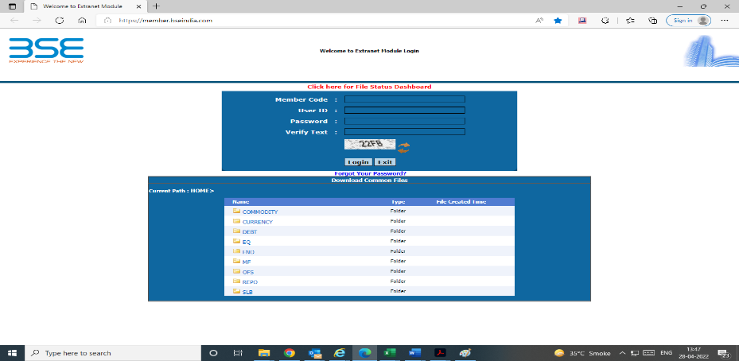

- Type the username and password in the relevant fields along with captcha verification & login.
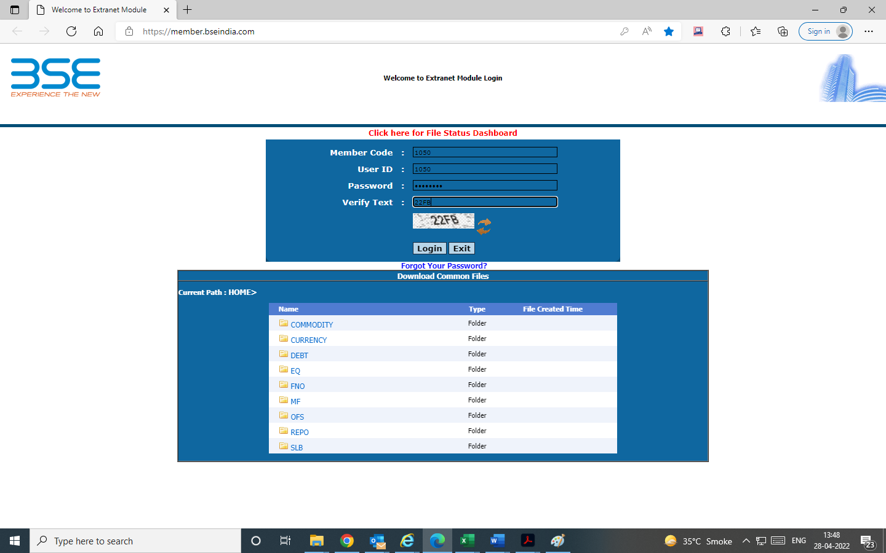
- Main Extranet interface screen as shown in below figure will be displayed

- Click on ‘uploads” for upload of client collateral allocation file. The cut-off time for upload of collateral allocation file will be till 8:00 pm.
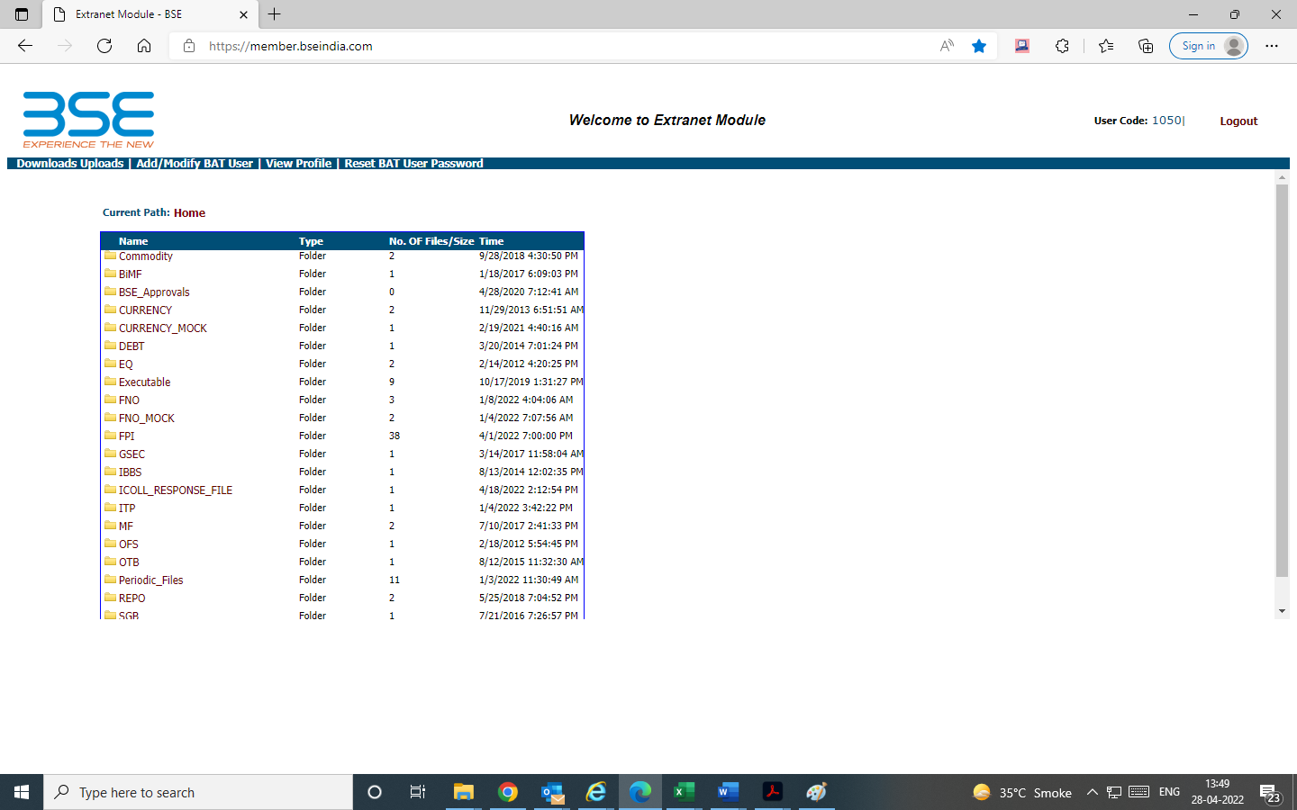

- In segment type field -- select ICCL Collateral allocation file upload. Sample upload file attached
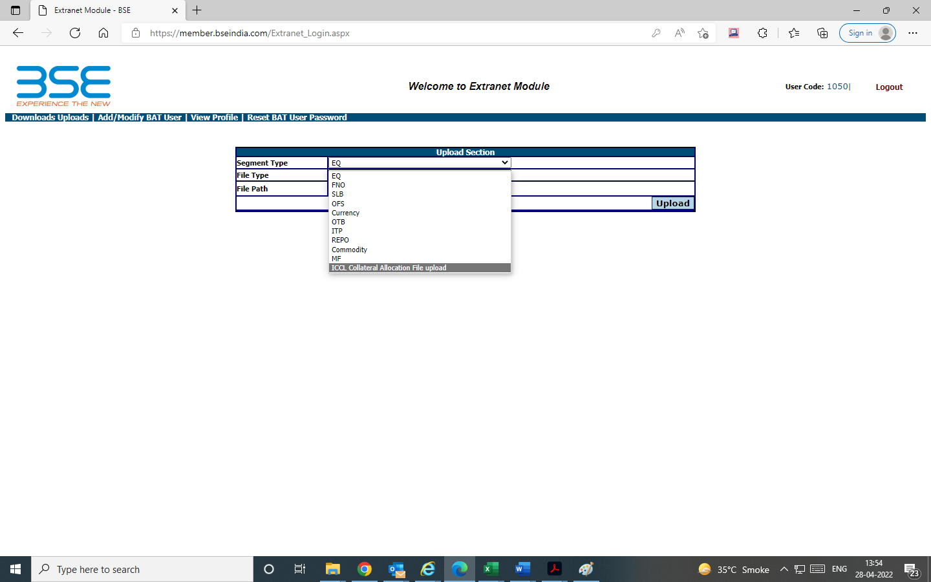

- Browse & Select file to be uploaded from client machine and click on upload as per the stipulated format. Refer the link provided in point No 1 above for file format.
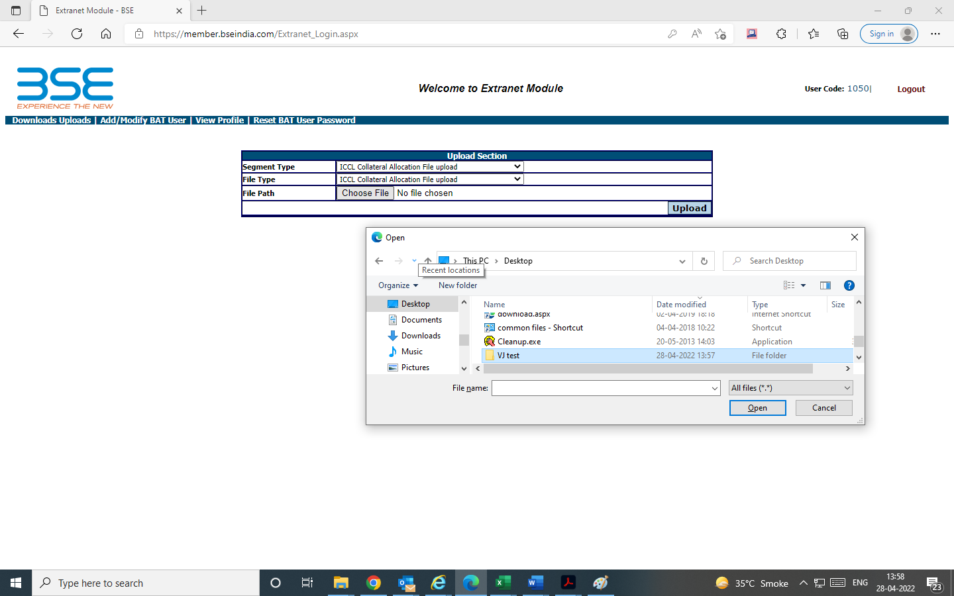

- Post upload of file, click on downloads - select ICCL response file to view details of file uploaded & response.

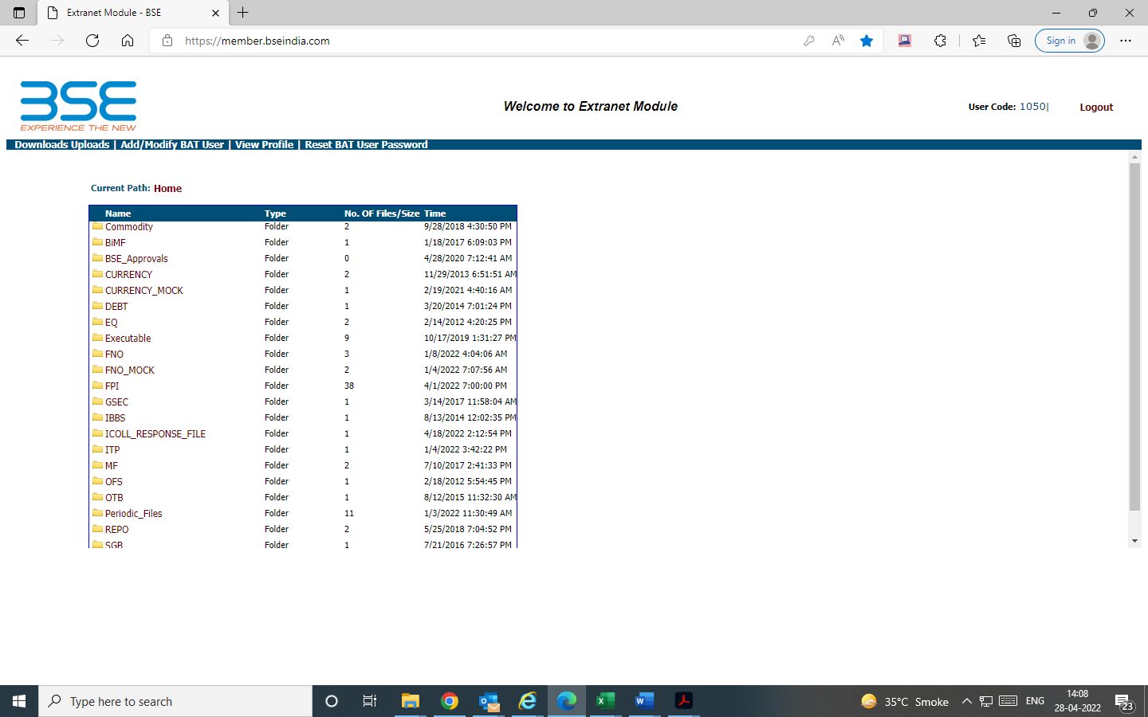

- Select Uploads---month---date to check details of successful file upload. Complete log will appear in file name
- Select Transaction---month---date to check details of response file.
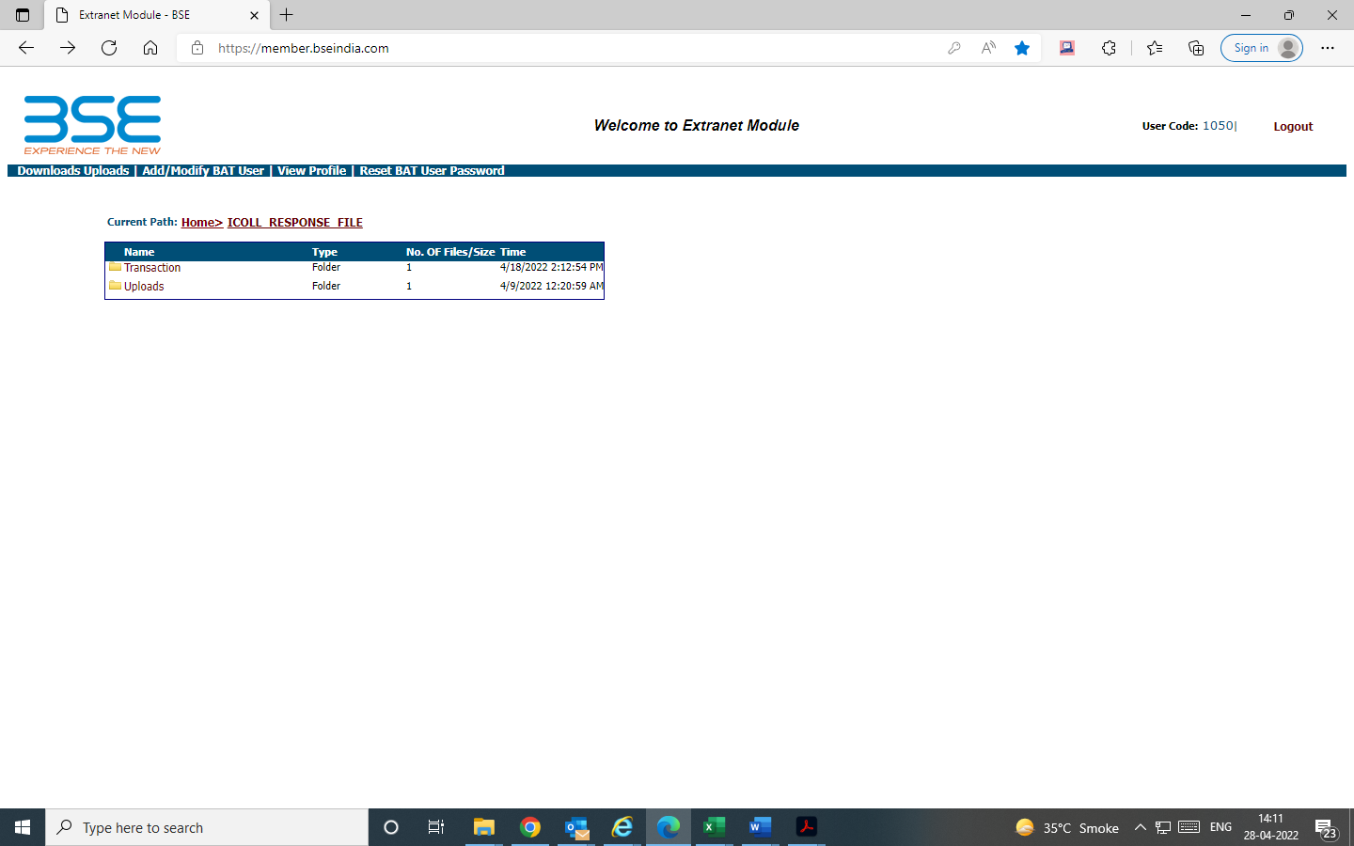

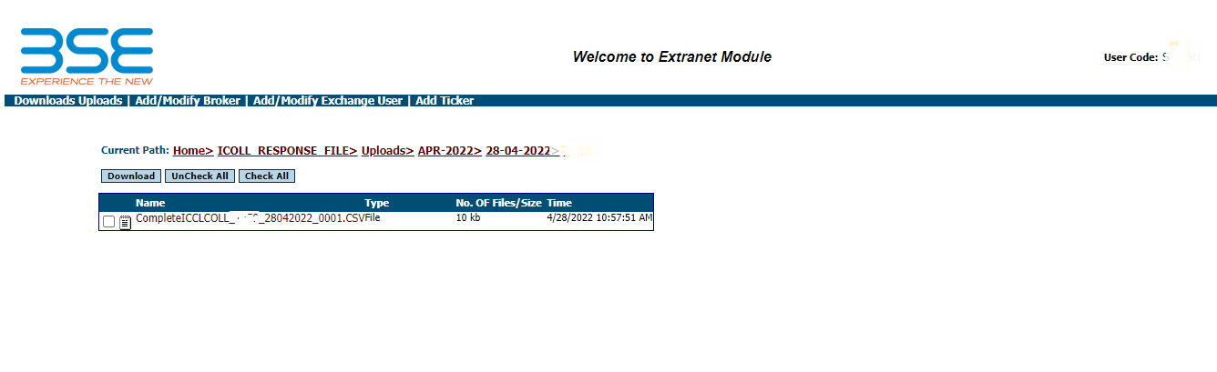
- Upload file log

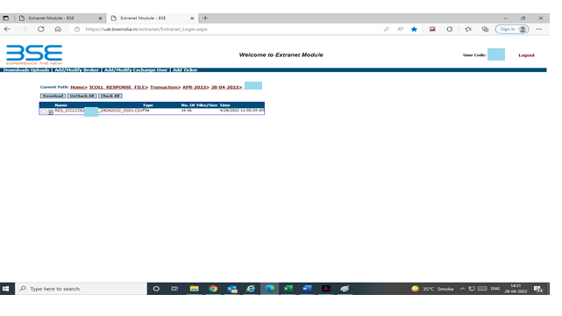
- Response File log

- Collateral Allocation details through API Facility
- For availing API facility, Members will be required to provide member code details along with IP details to ops@icclindia.com
- Post confirmation from ops team on successful IP whitelisting, API call can be initiated by Members.
- API response file will be available for member’s download on member extranet portal in downloads section- ICOLL Response file
API URLs
https://classapi.bseindia.com/api/Authorization/Authorize
https://classapi.bseindia.com/api/ClientBifurcation/ClientBifurcationImport
Sample message structure & API version attached for reference.

Post upload of Collateral allocation file & API initiation, members can view the status of Collateral allocation details on ICCL Collateral system
- ICCL Class Collateral Interface
ICCL Collateral system (CLASS) is a web interface provided to member brokers for cash collateral enhancements, Release of collaterals, transfer facility, viewing/download of various member reports i.e., Holding statement, EPN reports, client collateral allocation reports etc.
- LOGIN
Users can log on to ICCL Collateral system (CLASS) using the username and password provided by User trdops team.
Coordinates of user trdops team for requesting new password & resetting password
Email- user.trdops@bseindia.com;
Contact No: 22728215/8005

Collateral Interface access steps
- Click Internet Explorer
- Connect to the below URL for application access in Equity cash/Equity derivatives/Currency Derivatives/Commodity Derivatives/SLBS segments.

https://classseg.bseindia.com/Application/AppLogin/Login.aspx (NEW Collateral link)

- Existing application URL https://class.bseindia.com will be available for cash collateral enhancements in OFS/ITP/NCB-Gsec segment only.

- Below login screen will be displayed
https://classseg.bseindia.com/Application/AppLogin/Login.aspx
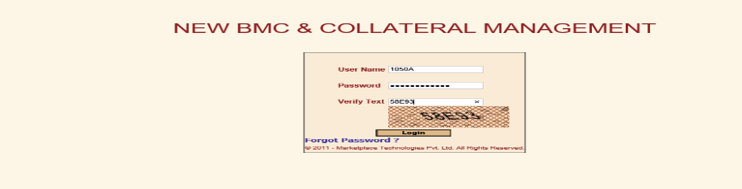
- Type the username and password in the relevant fields along with captcha verification & login.

- Client Collateral related reference reports

- Main Collateral interface screen as shown in below figure will be displayed
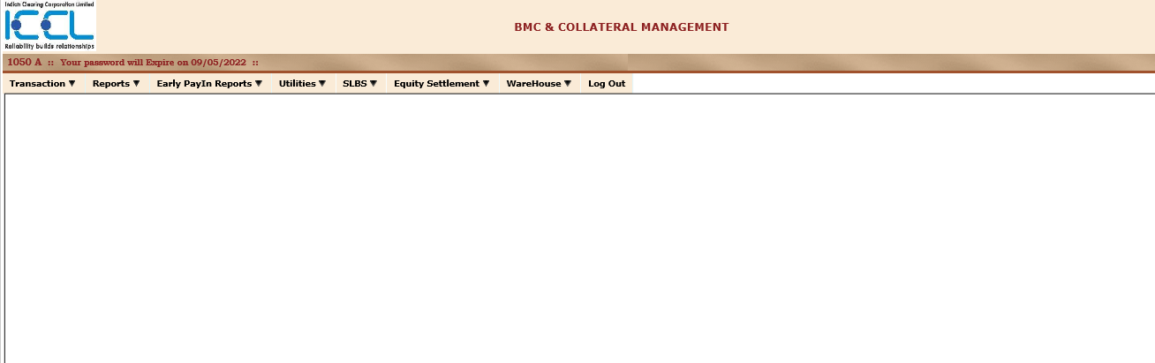
- Click on reports-member reports- collateral file allocation file upload status to view status of collateral allocation details
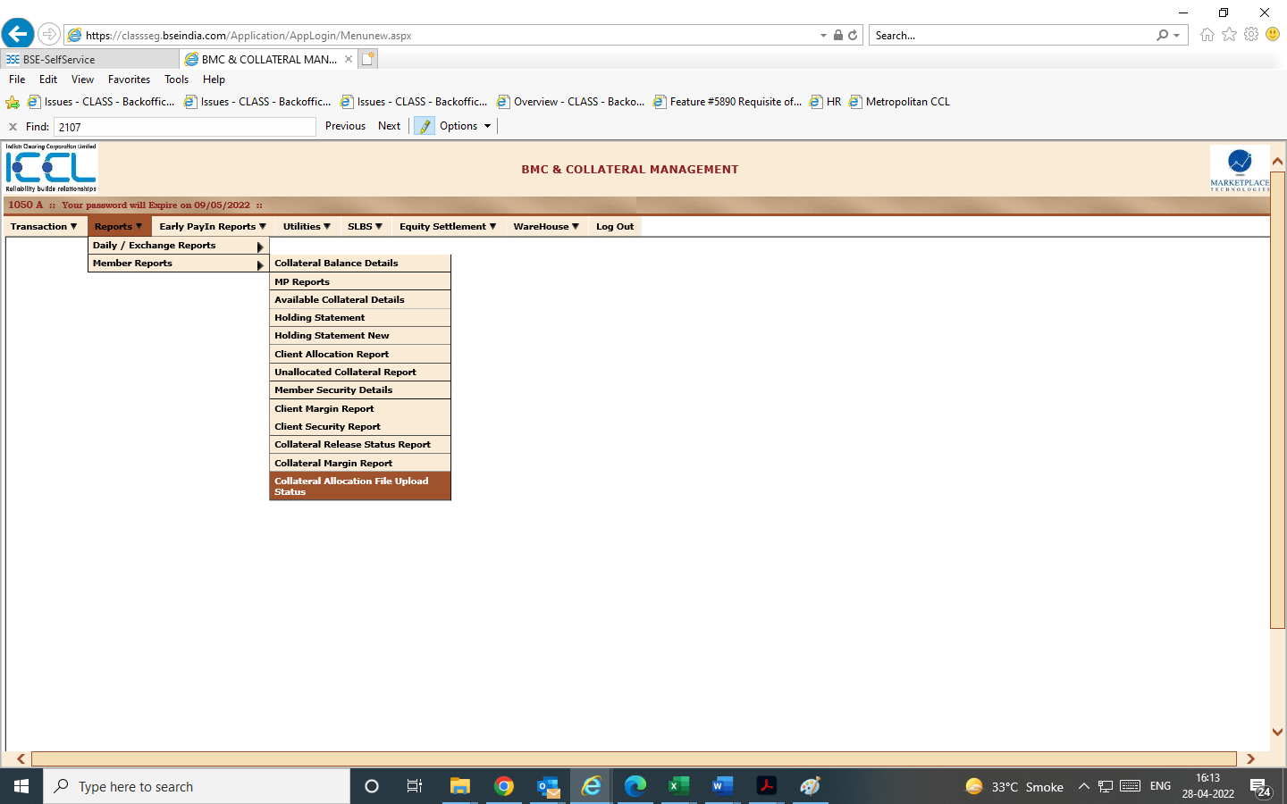

- Select import date & click on view for details
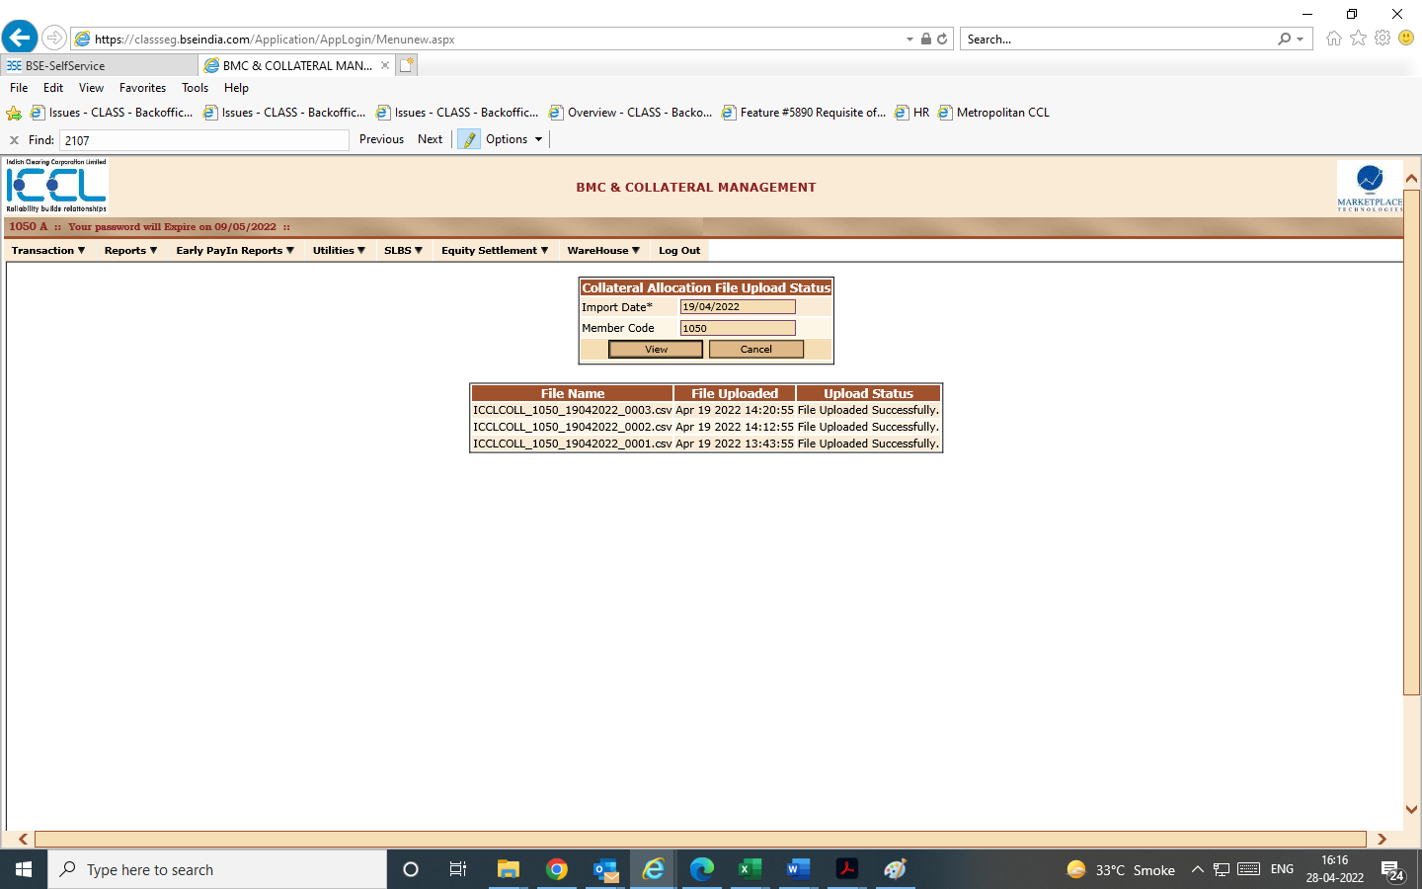

- Member can additionally download (export to csv) client collateral allocations details by selecting Client allocation report for the requisite segment & date.
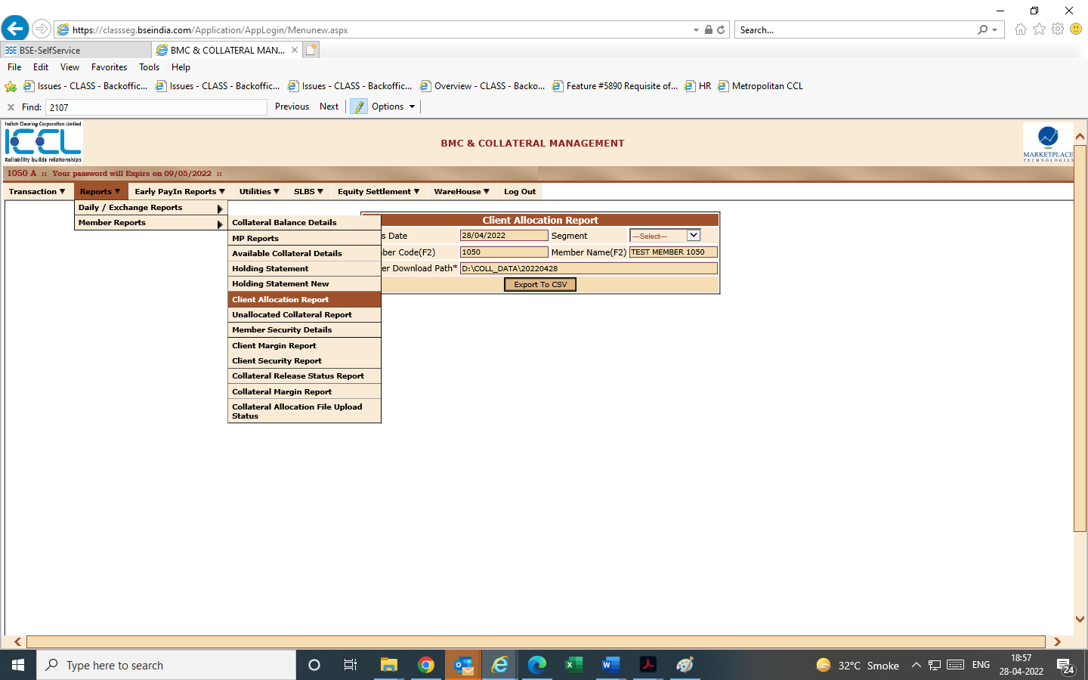
Below report will be downloaded giving details of client allocation
Sr. No | Field Name
1 | Date
2 | Segment
3 | Clearing Member Code
4 | BSE Trading Member Code
5 | Trading Member Code as received from Depository System
6 | Client Code
7 | CP Code
8 | Total Pledged Quantity
9 | Non-Cash Equivalent Collateral after haircut
10 | Total Commodity Collateral
11 | Allocated Cash/Cash Equivalent Collateral
12 | Total Collateral
13 | Idle Non-cash equivalent collateral
14 | Idle Commodity Collateral

- Member can select unallocated collateral report to view unallocated collateral report details through the below menu
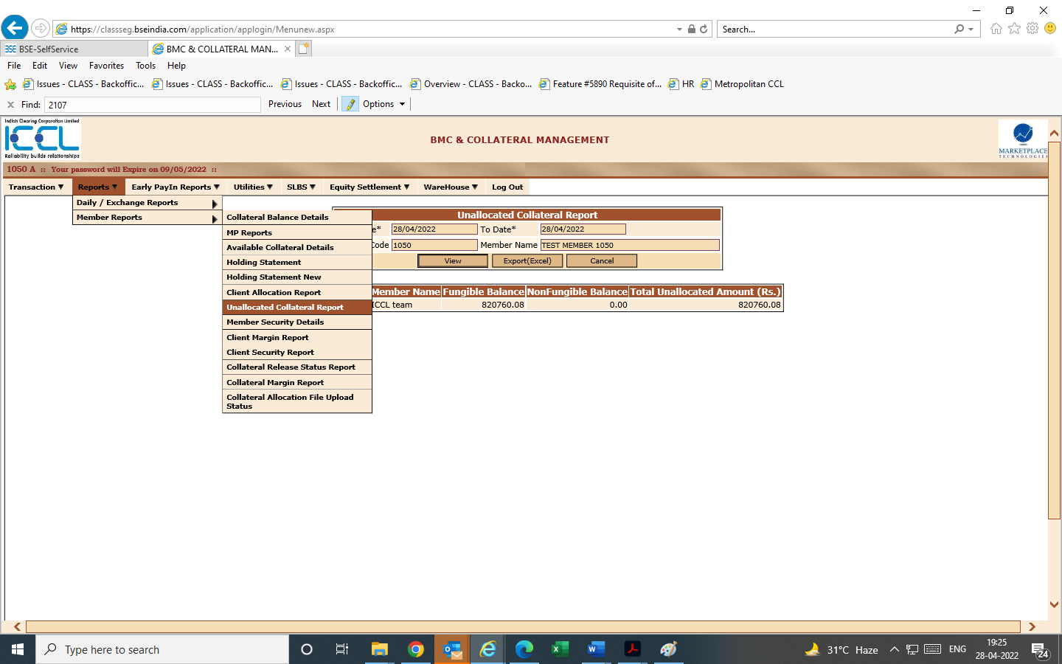

- Members are required to select Holding statement option for viewing/download segment wise holding segment details.
- Members are required to select Holding statement new report option for viewing/download common pool holding statement details.
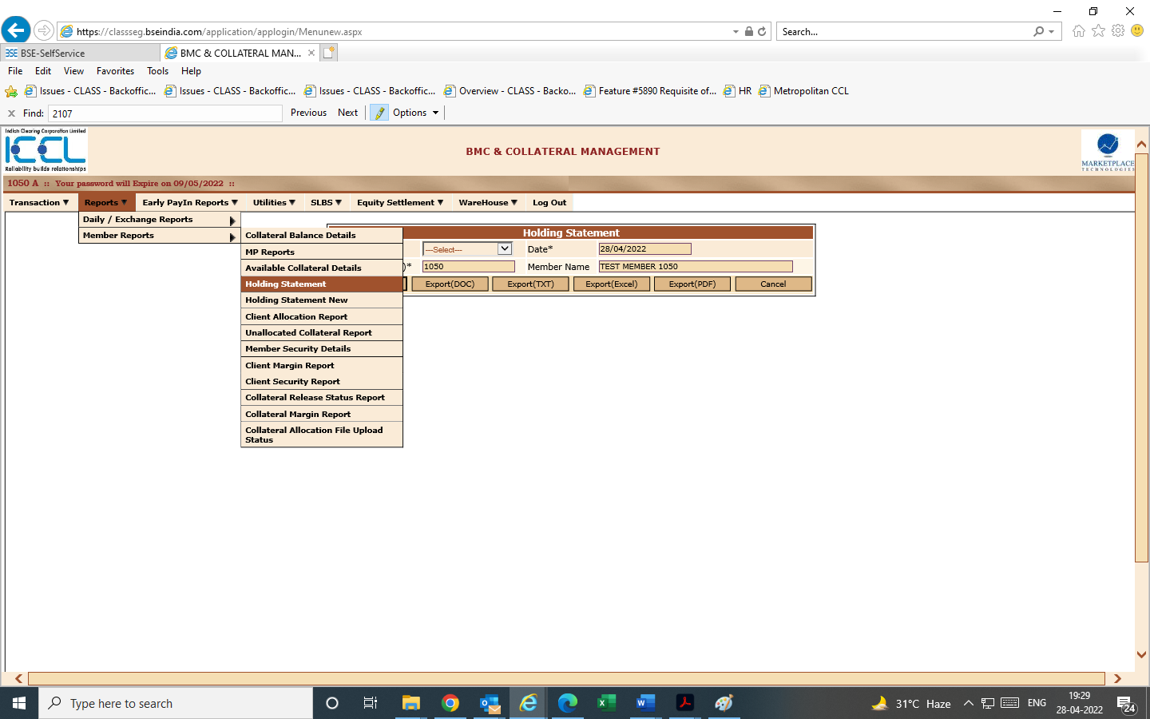

- Re-pledged security details report can be viewed/downloaded by selecting option client security report under member reports section
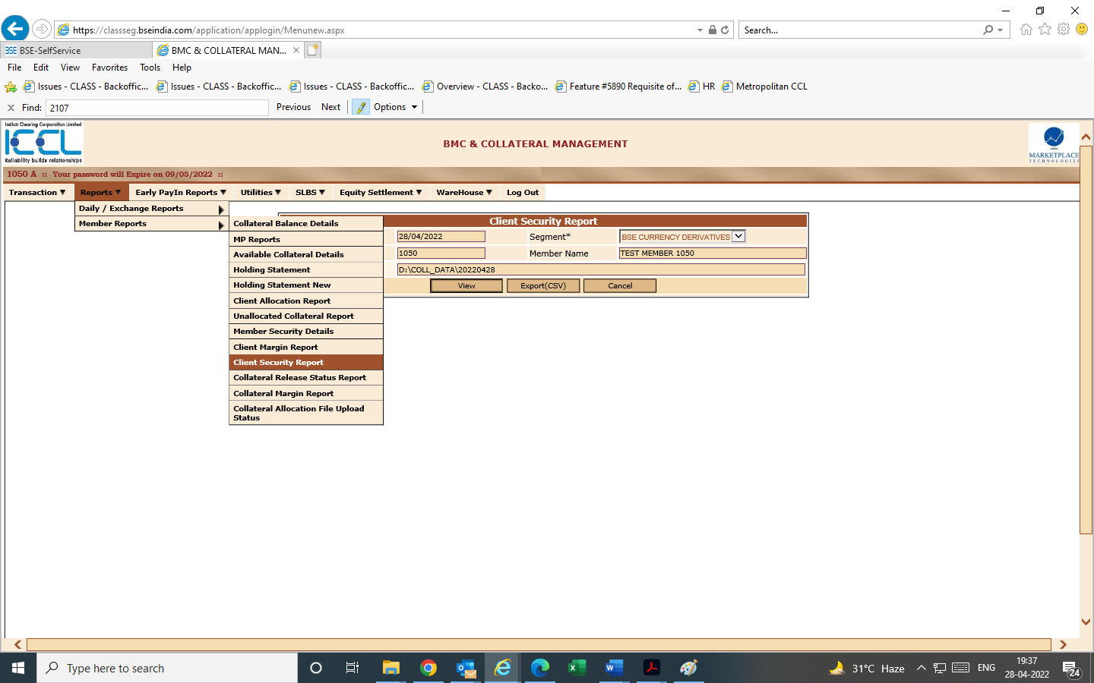
- Collateral Transfer report screens

- Members can avail security transfer through below screen-based option. Transaction- deposit/withdrawalcollateral transfer-Input details & save.
- Cash & cash equivalent transfer details can be availed through ICOLL file upload. Action flag to be T in Sr. No 15
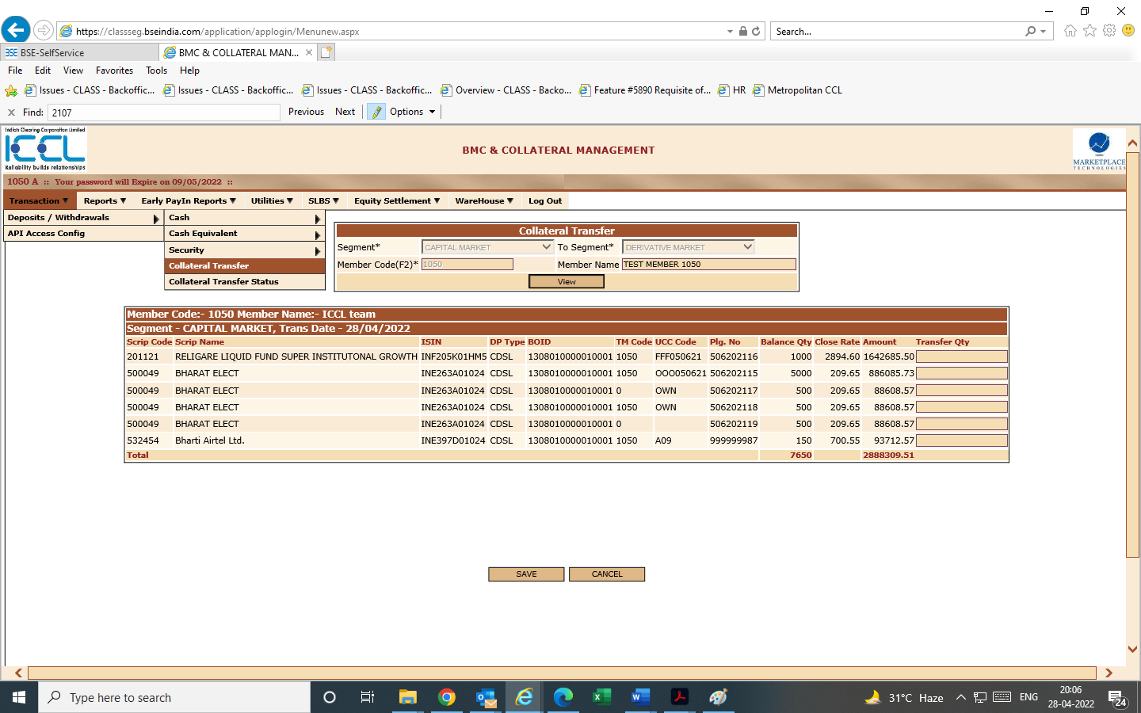

- File upload facility will also be available for inter segment security transfer. Refer below menu screen. Members can select & import the file as per below stipulated format.
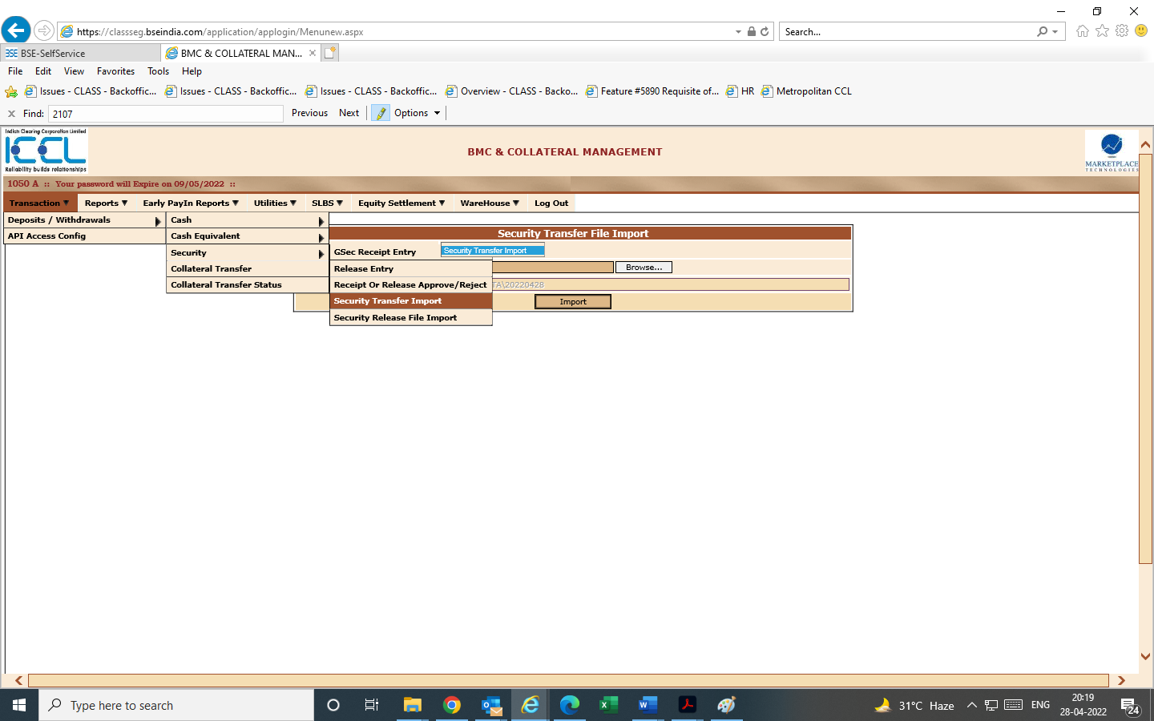

- Below collateral transfer status report will provide status of collateral transfer. Members to add the requisite details

File format & sample file for security transfer/security release

- Members can view collateral transfer status details through collateral transfer status report. Post import of security release file, a successful pop-up message will be displayed along with download of response file.

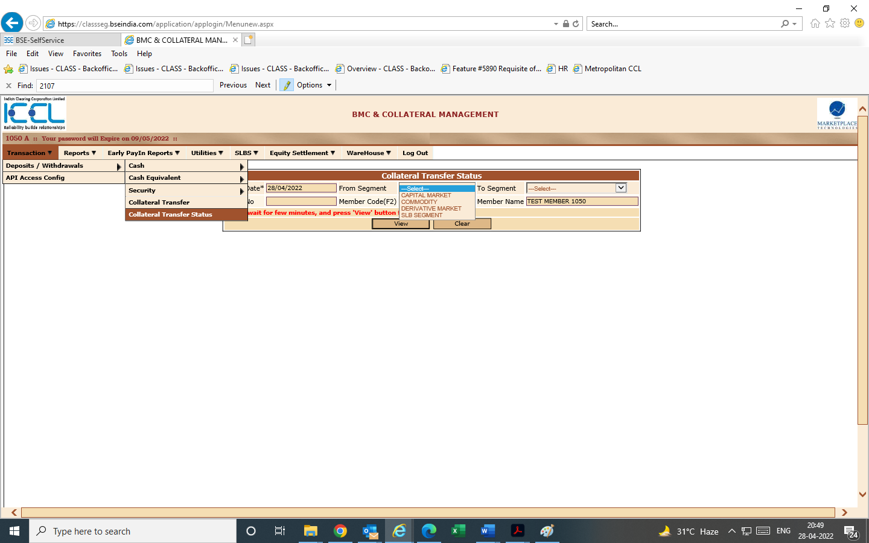

- Collateral Release report screens

- Respective collateral type withdrawal request can be provided in Collateral system by selecting the respective collateral type i.e.,
- Cash (same day cash release- release time to be selected)
- Cash Equivalent
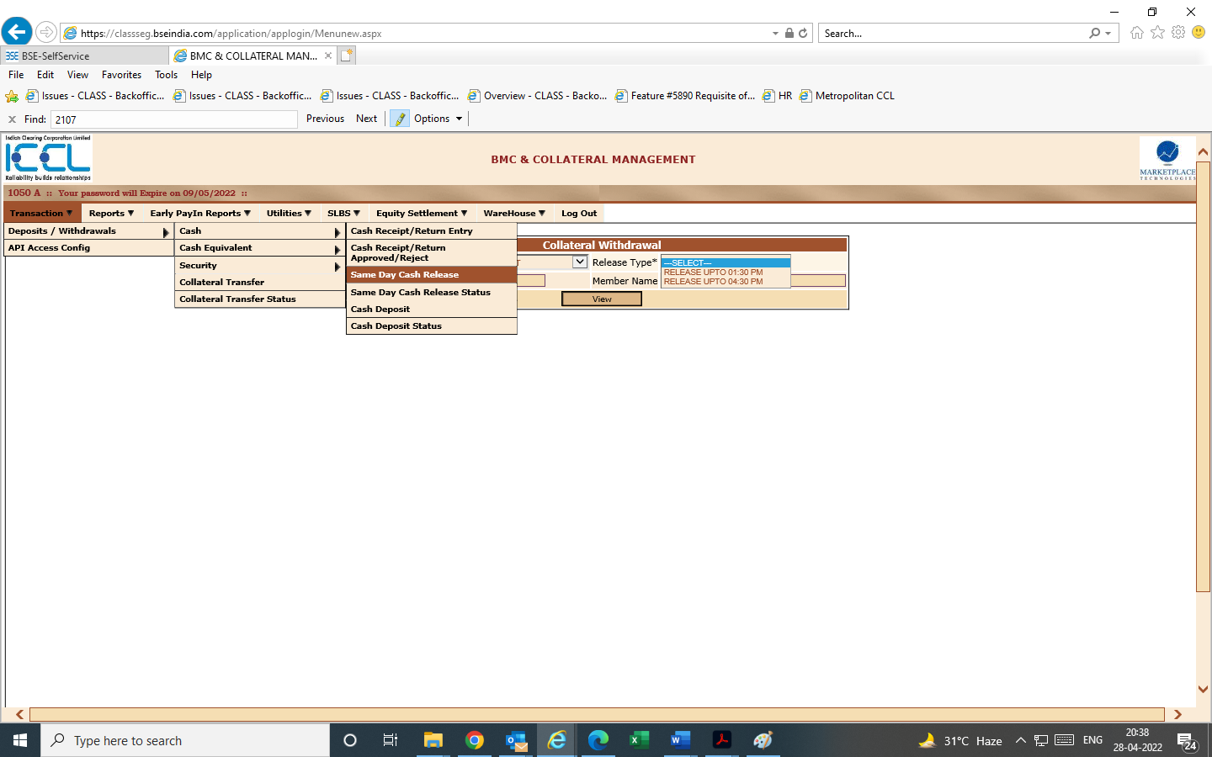
- Security (security release through screen based & file import)- File format provided above for security release & response. Post import of security release file a successful pop-up message will be displayed along with download of response file.

- Early Payin of Funds
- For EPF, Manual entry to be done in CLASS by clearing Member under below path:-

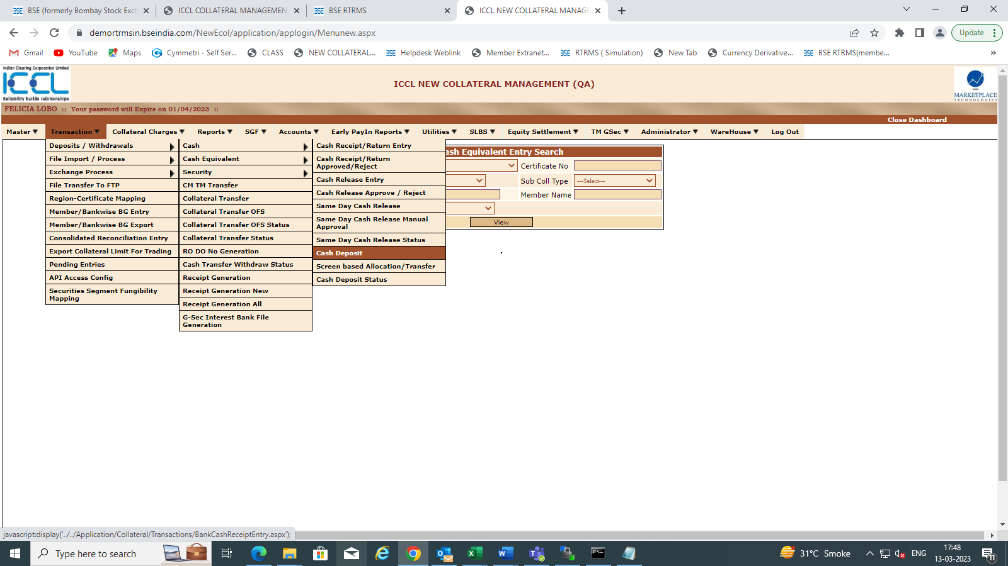
Requisite details to be updated by User before uploading EPF files under below screen.
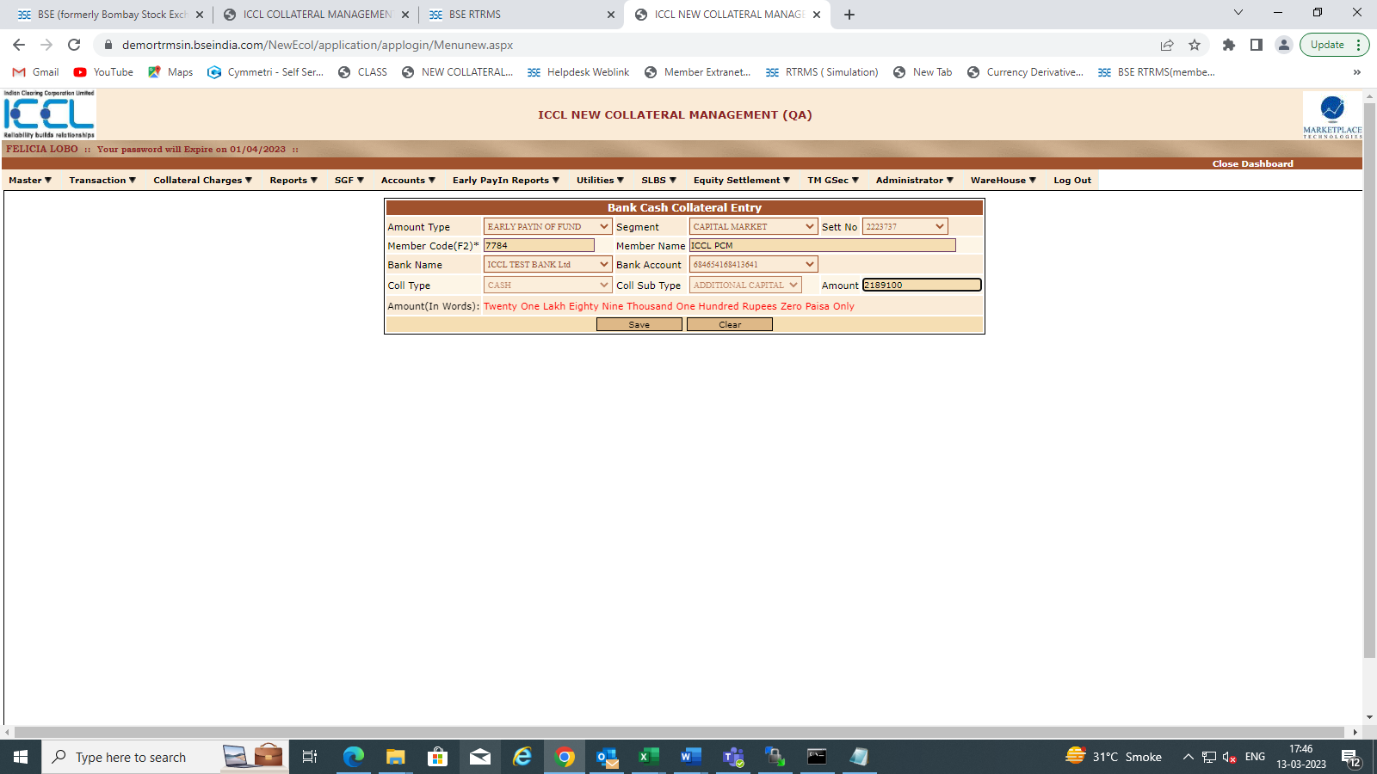
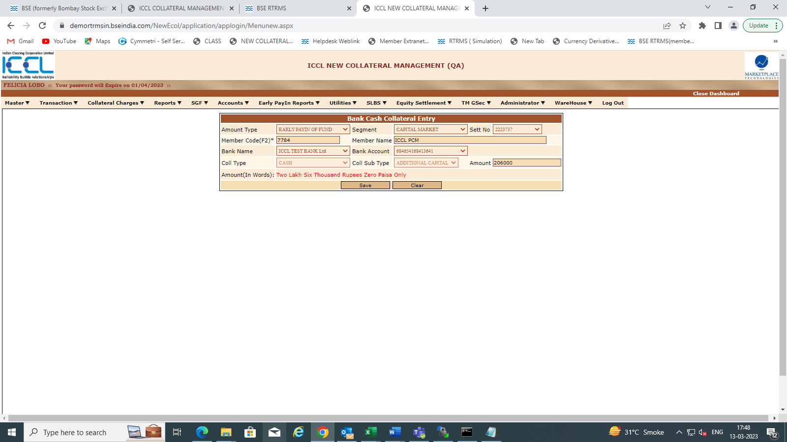

- EPF upload file format: -
After manual entry, CM needs to upload EPF file as per below format on the member extranet portal under upload section selecting EPF file type option.

- After Uploading files, user can check file upload status in Collateral Module under below path:-
Login to Class --- Early Pay-In Reports --- File Upload status --- Select File Type --- Early Payin of Fund
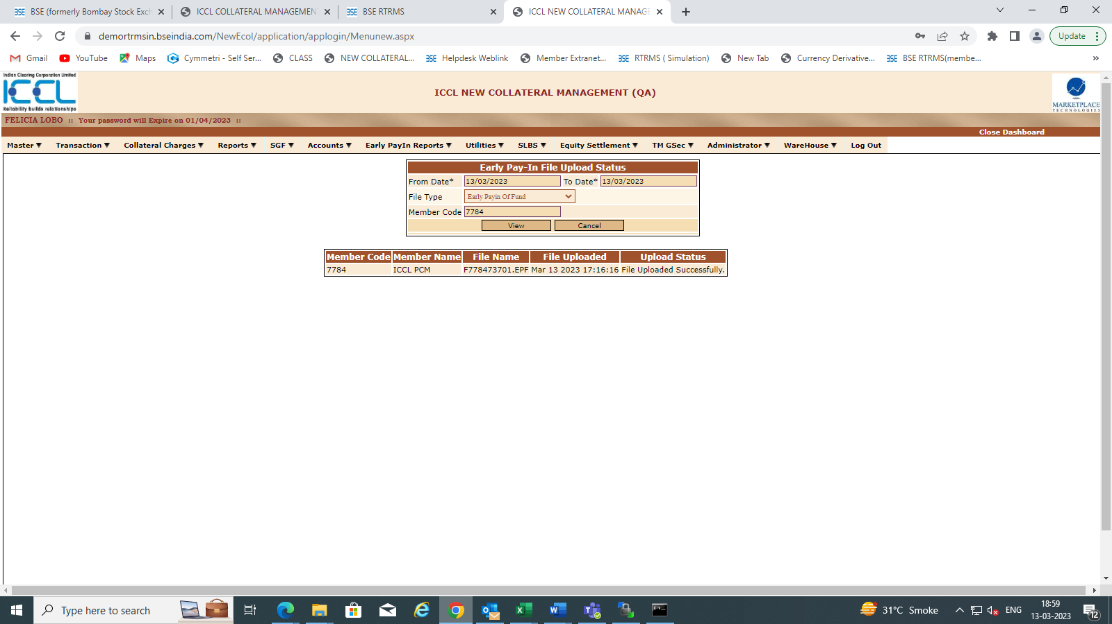
- User can view amount approved by bank and file uploaded in extranet for EPF under below path by providing basic required details.

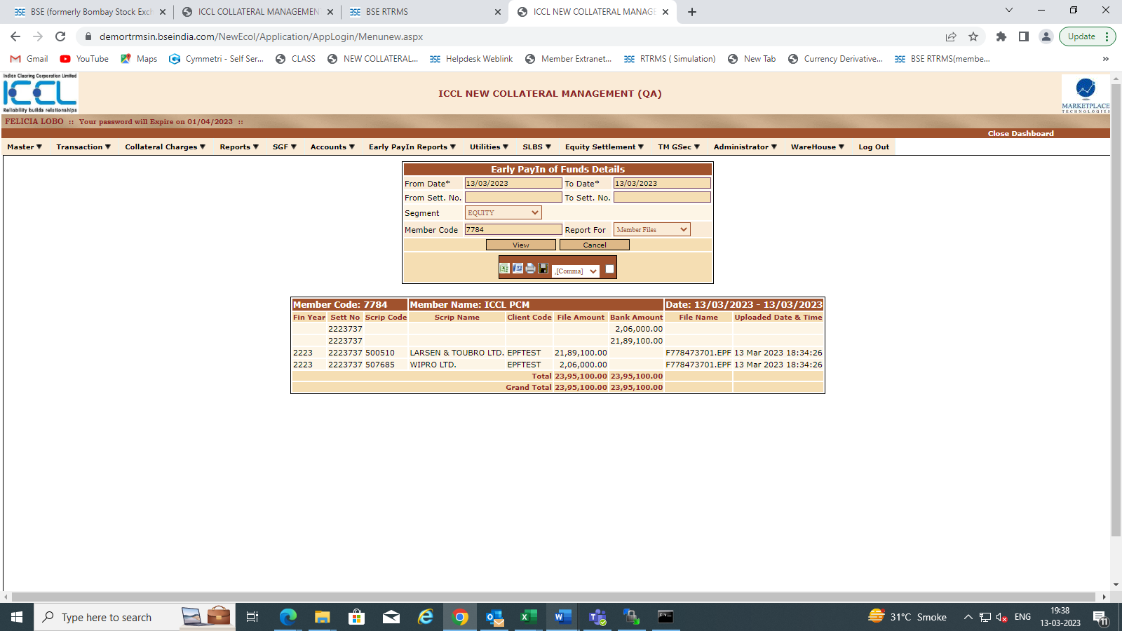

- User can view effect in RTRMS also.

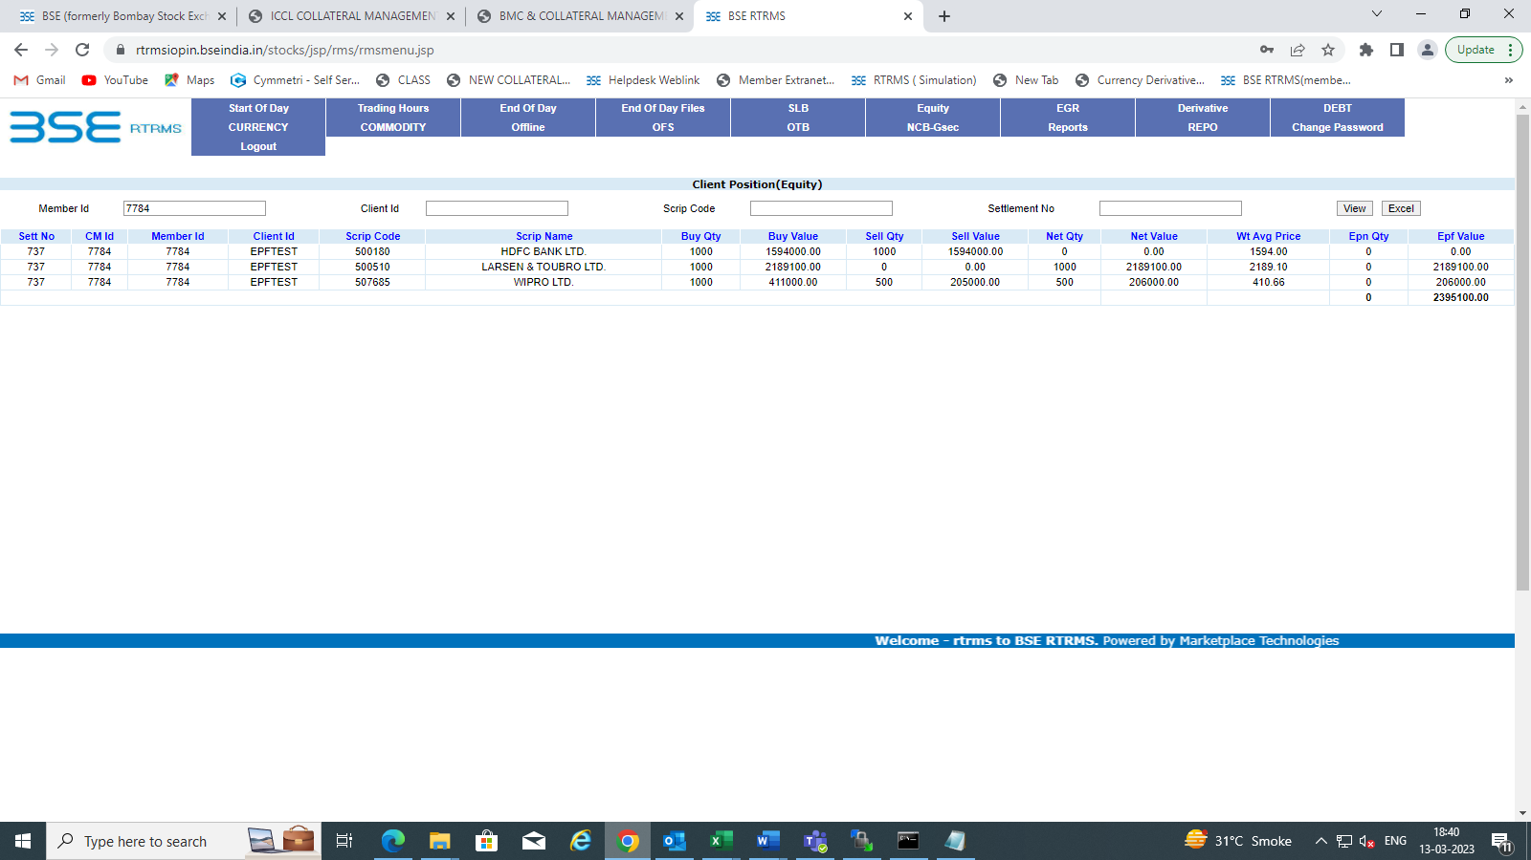

- Response file for EPF can be viewed on Member Extranet Module under below path Home-> EQ-> Transaction-> Current Month & Year-> Current Date.
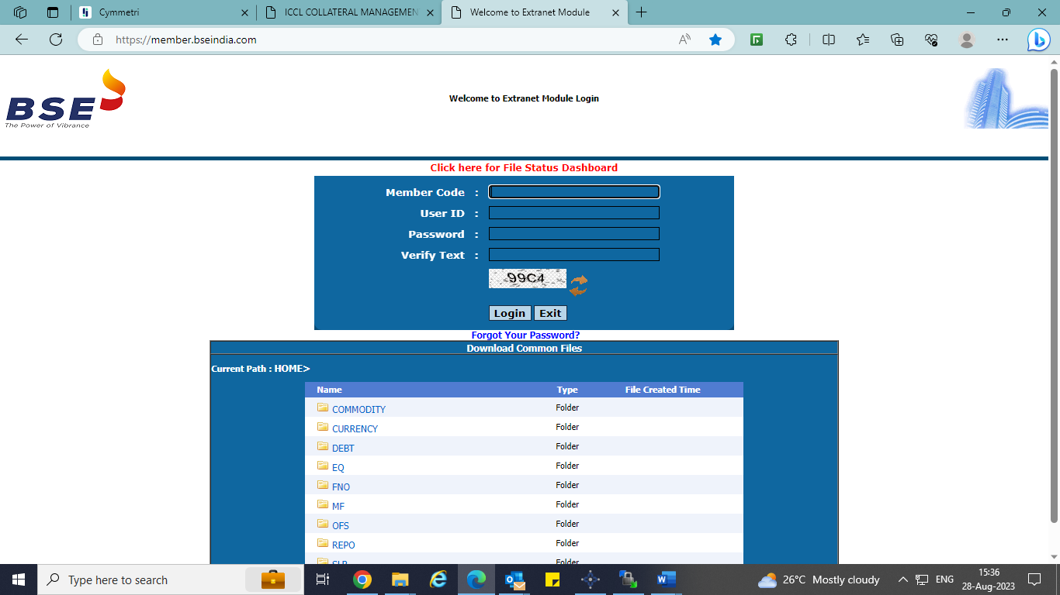

- Early Payin of Funds Response file format.

File Name | EPF Response File
Nomenclature | ICCL_EPF_RES_<Member Code>_DDMMYYYY_nn.csv
Path | Extranet
File type | csv
Sr. No. | Field Name | Data type
1 | Clearing Member Code/Custodian code | VarChar (6)
2 | TM Code/CP Code | VarChar (12)
3 | Client Code | VarChar (12)
4 | Batch Date | DD-MMM-YYYY
5 | Batch number | Number
6 | Number of records | Number
7 | Scrip code | VarChar (12)
8 | Settlement No | VarChar (10)
9 | Financial year | VarChar (4)
10 | EPF Amount | Number (15) (in INR)
11 | Filler | Future use
12 | Success/ Reject Flag | Varchar (1)
13 | Uploaded Date & Time | date time
14 | Error reason (as per existing validations) | Varchar (100)

Member queries/clarifications can be escalated at ops@icclindia.com/collaterals@icclindia.com

***end of document***

